AI Use Declaration Form
Course: Introduction to Artificial Intelligence
Lab Title: Lab 1B
Student Name: Caleb Winner Koufie
Student ID:31042028
GitHub Repository Link: https://github.com/CALEB-KOUFIE/Caleb_Koufie_Lab1.git
Date Submitted: 20/06/2026

1. AI Use Summary
Question | Student Response
Did you use any AI tool for this lab? | YES
Estimated percentage of work influenced by AI | 12%
Did you attach evidence of AI use where applicable? | YES

2. Details of AI Use
Complete the table below for each AI tool used. Add more rows where necessary.
Name of AI Tool Used | Purpose for Using the Tool | Prompt or Instruction Given to the Tool | Part(s) of the Work Influenced by the Tool | How I Verified, Edited, or Improved the AI Output
ChatGPT | For generating the Terrain cost | generate a Terrain costs (same shape as the grid), if using WeightedGridProblem for this grid | Custom grid part | Didn’t edit this output
ChatGPT | For correcting written statement | Correcting written statement | Explain some concept | It was personally written and I just made chatgpt correct my statement and sentences this my keyboard was malfunctioning
ChatGPT | Correcting and understanding a code | get an error: Cannot access attribute "h" for class "IDAStarSearch*" Attribute "h" is unknown | Helped in debugging a code since it was giving me error | Maintained the code

3. Attachment of AI Output Evidence
Where required, attach evidence of AI use. Tick all that apply. Add more rows where necessary.
Evidence Type | Attached? (Yes, No, N/A) | File Name
AI-generated draft
Prompt history
Screenshot of AI interaction | yes
Exported AI conversation
AI-generated code snippet
Revised version showing student input

4. Student Declaration
I declare that:
Declaration Statement | Response (Yes/No)
The submitted work is my own work. | Yes
Any use of AI tools has been clearly declared in this form. | Yes
The prompts, instructions, and AI-generated outputs have been disclosed where applicable. | Yes
I reviewed, tested, edited, and improved any AI-generated content before submission. | Yes
My AI usage does not exceed 25% of the entire work. | Yes
I understand that undeclared or excessive AI use may be treated as academic misconduct. | Yes

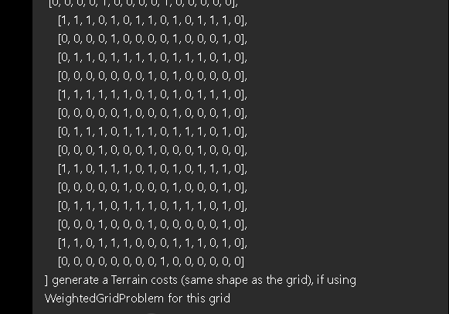

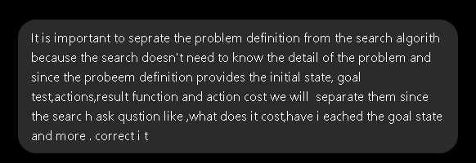

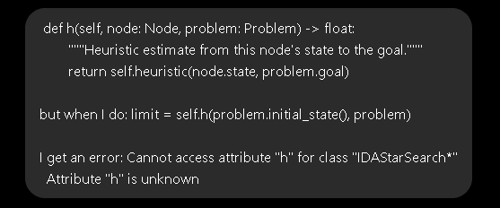
Student Signature: Caleb Winner Koufie
Date: 20/06/2026

